### Easter Bunnies Slice Form Diorama

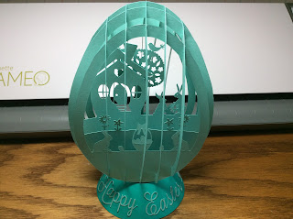

I created a diorama of an Easter bunny scene. I used a previous egg slice form that I designed and added the interior scenery. There are three sets of slices. The first slice is the center one. The second slice is the next largest one on each side of the center. The third slice is the smallest and it is attached on the outermost notch on each side. I recommend cutting all of the pieces and placing them on a table in consecutive positions so that you do not get confused as to their placement because size does matter.

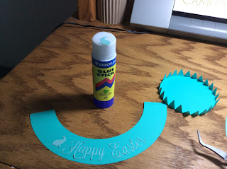

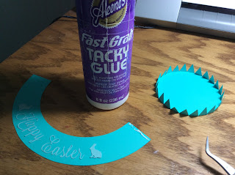

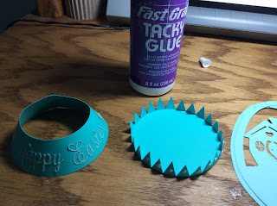

Make the base by attaching the Easter greeting. Bend the tabs as shown. Glue the side into a cone. Glue the base to the side.

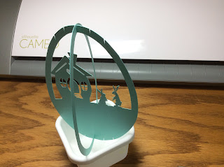

The slices be attached starting at the center and going outward. Slide the largest two pieces together at the center notch.

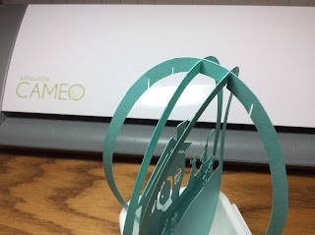  
  
Slide the tree slice to the back of the house slice at the next notch. On the front side of the house, slide the flower slice to the next notch. Repeat this for the basket slice on each side.

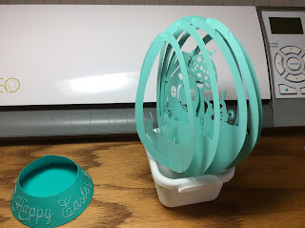

All of the picture pieces will now be attached.

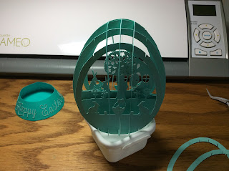

The pieces that are left are the cross slices which are plain. These slices need to be attached by size with the largest piece attached first on each side. The smallest slice is then attached, one on each side, to complete the diorama.  
  
  
Happy Easter!